# Set up Jenkin & Docker in AWS EC2

# navigate to EC2 page then click Launch instances button to launch new instance  
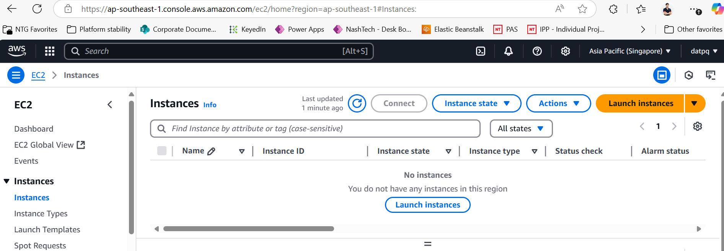

# input information  
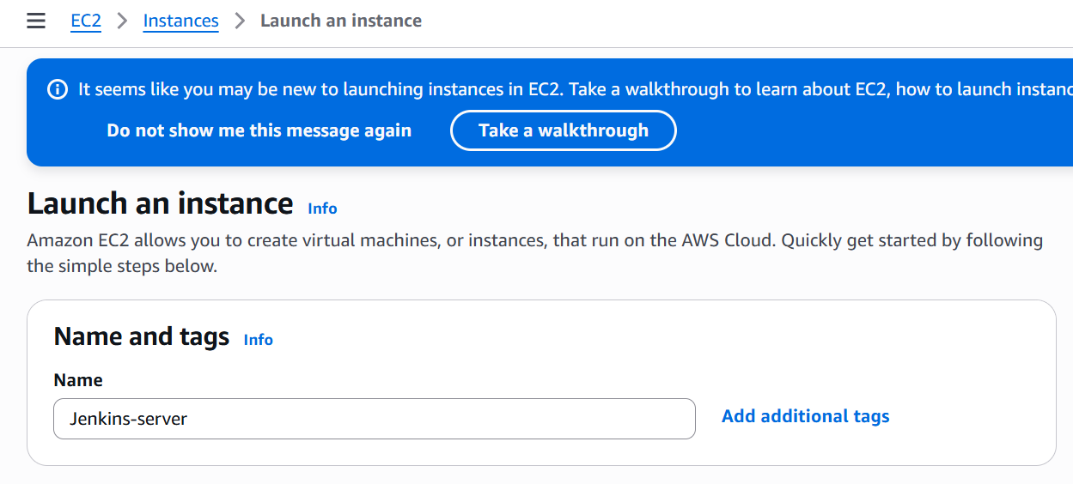

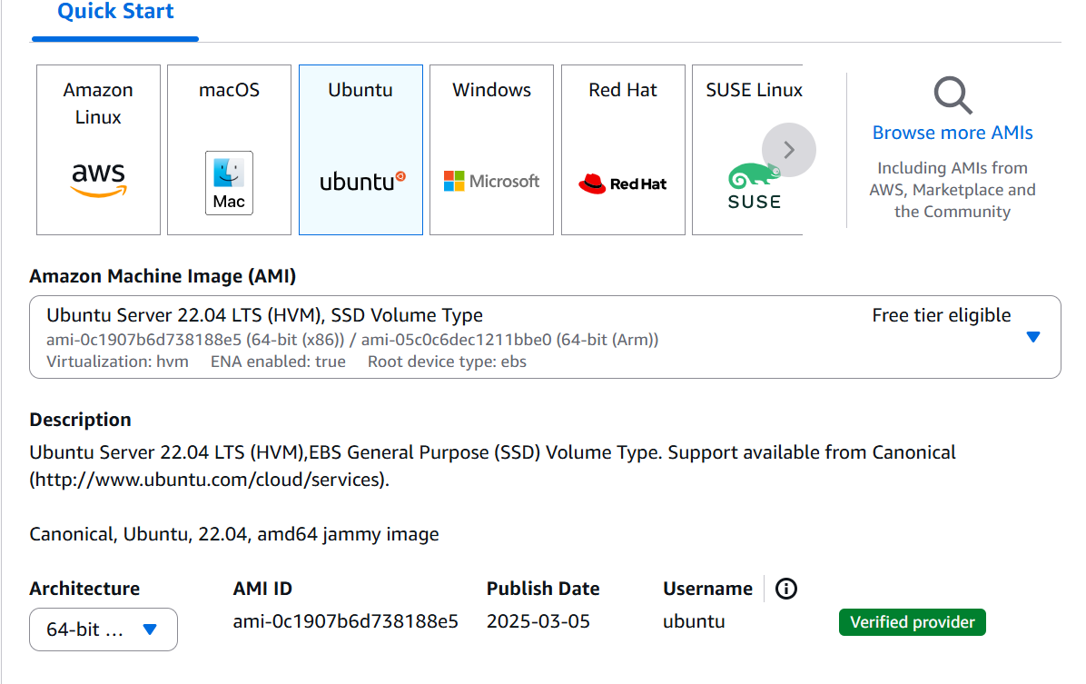

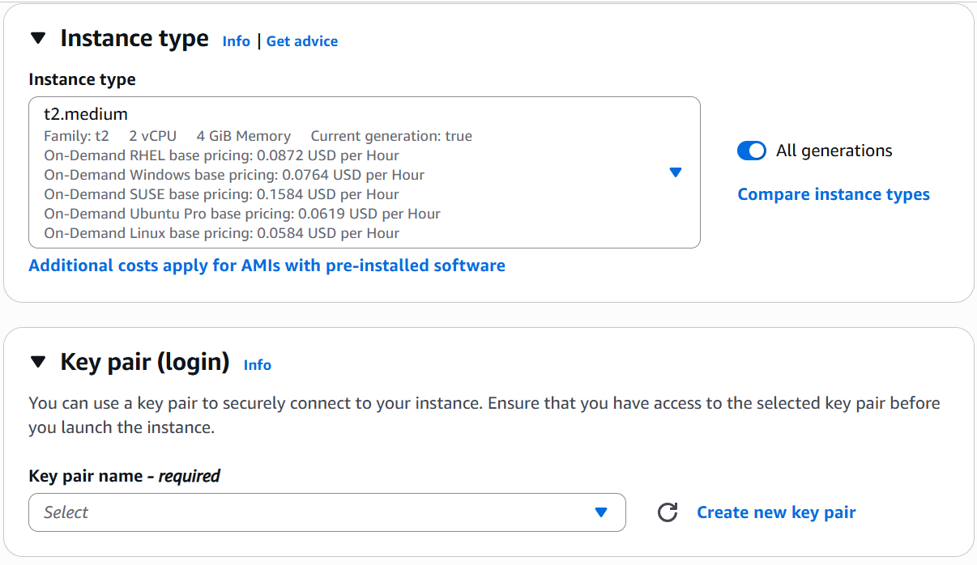

# create new key pair  
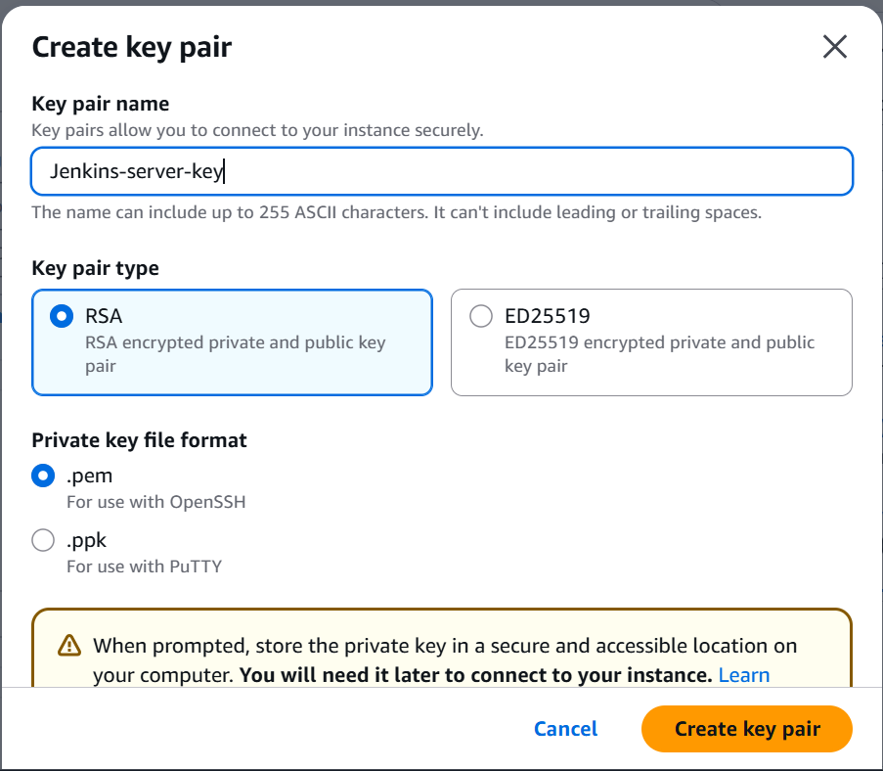

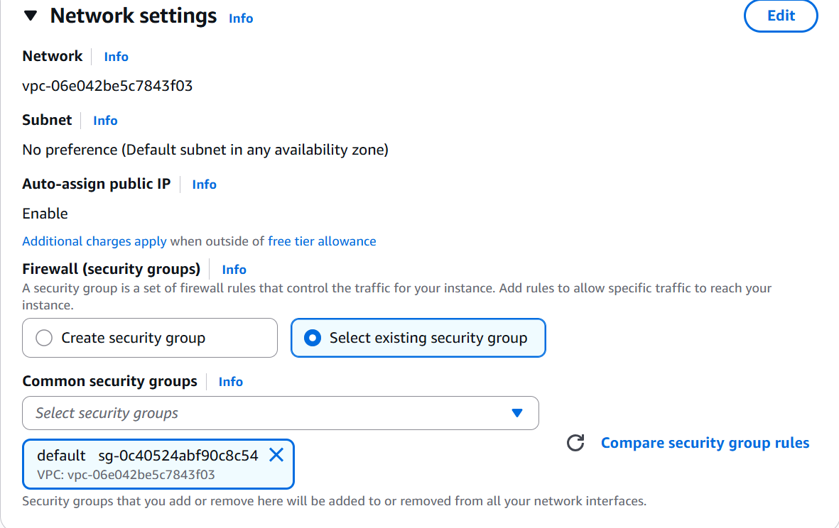

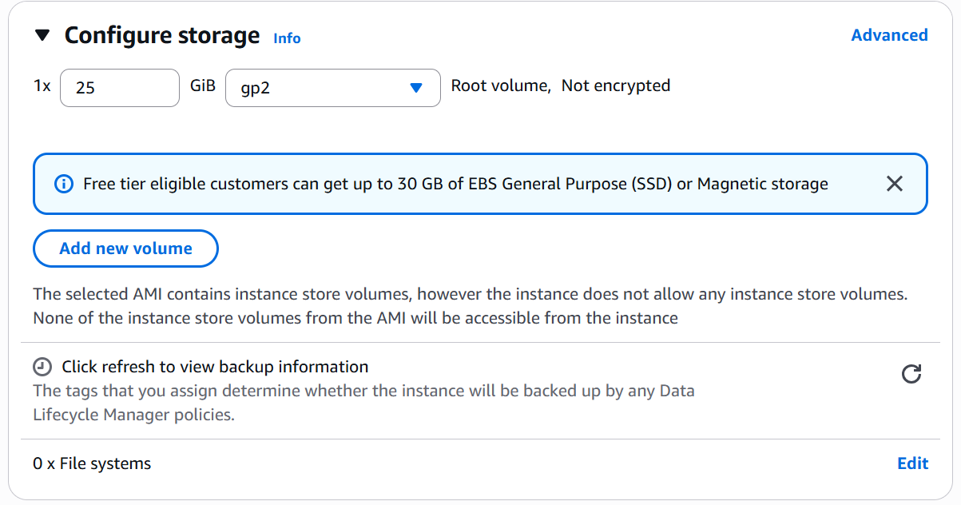

# review instance summary then click Launch instance  
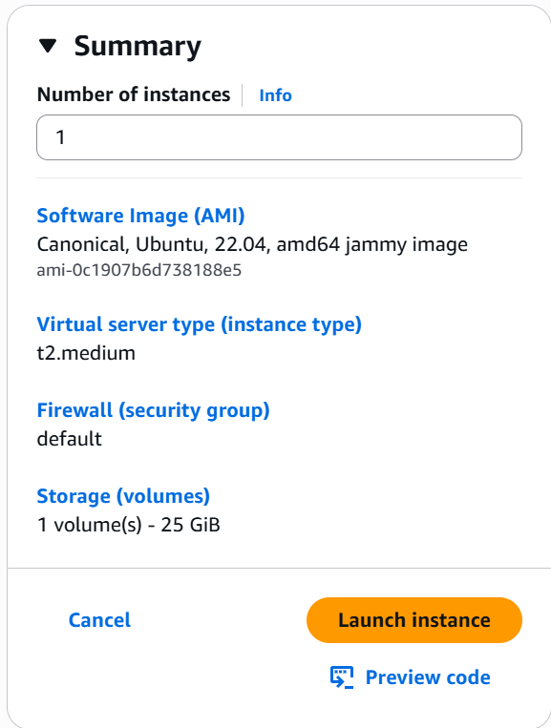

# EC2 instance is created  
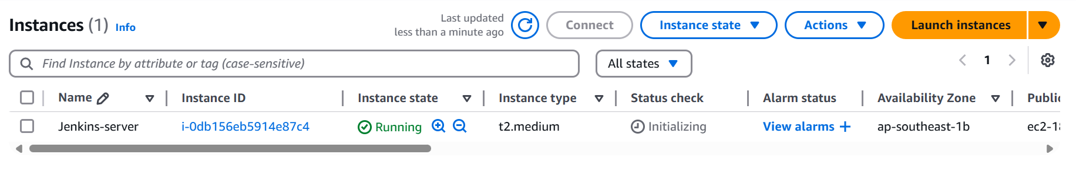

**Setting allowing access to Jenkins-server**

# click Security groups link of EC2  
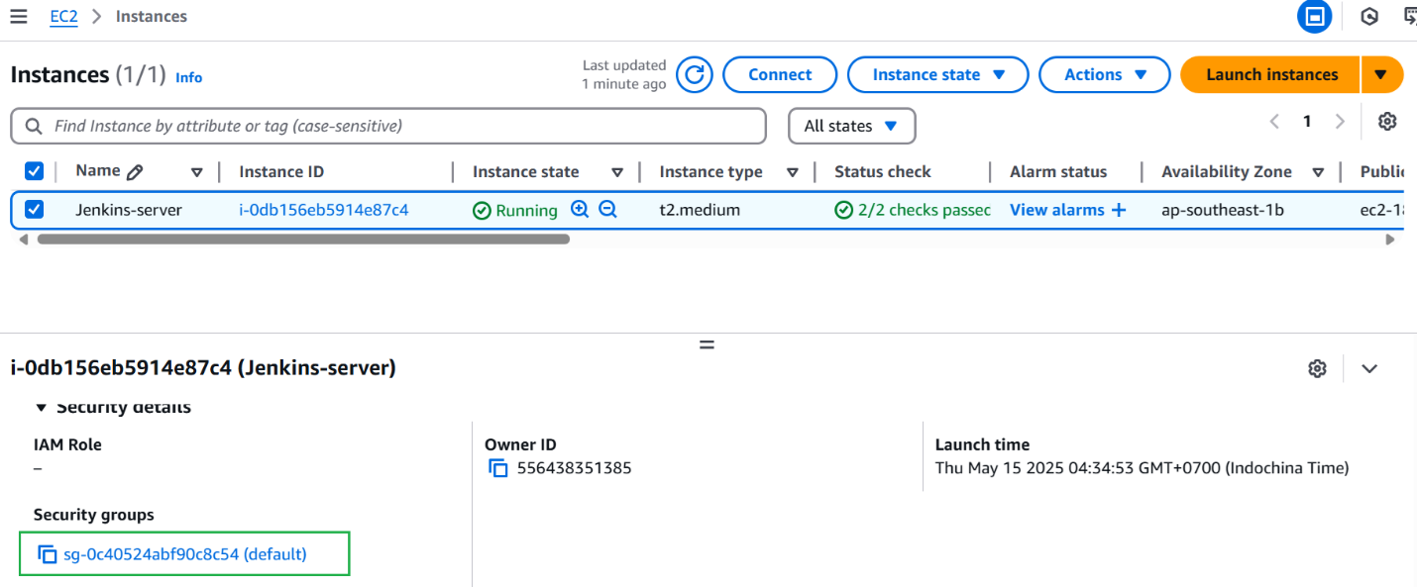

# click Edit inbound rules  
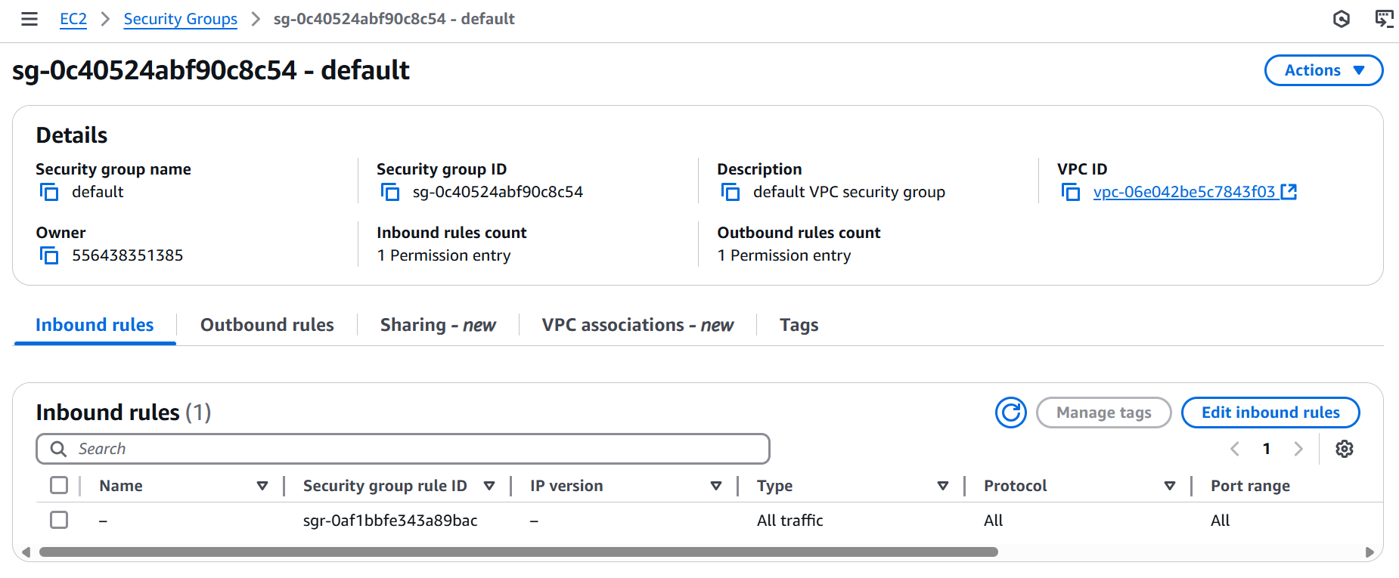

# add SSH rule as below => Click Save rules  
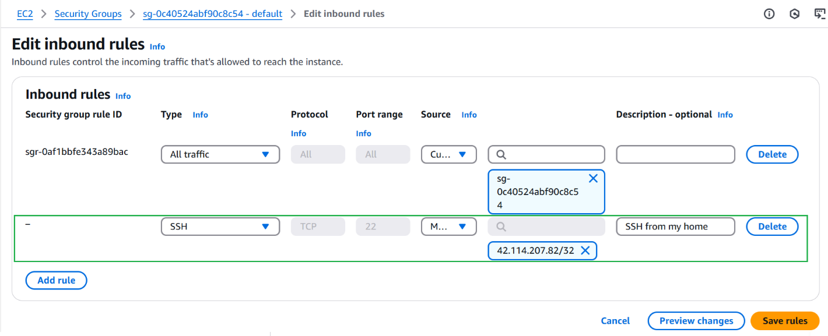

# add TCP rule to allow TCP port 8080 (8080 is default port of Jenkins)  


**Login to newly created EC2 to install Jenkins and Docker**

# click checkbox in first column => Connect  
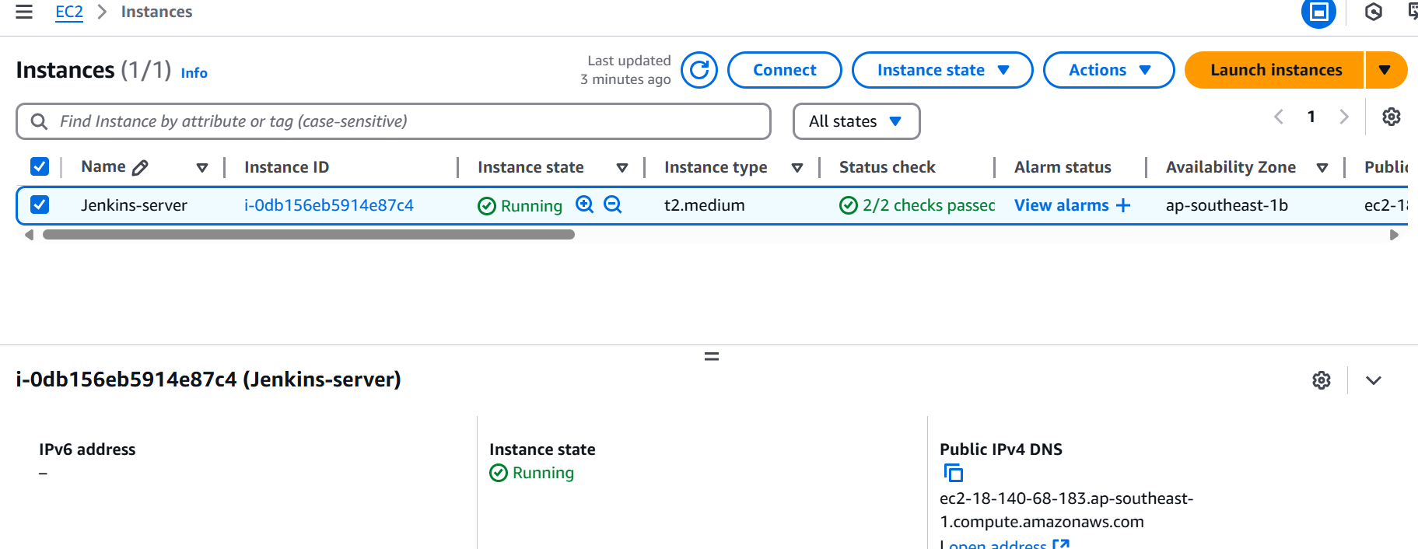

# click SSH client then follow the instruction to connect  
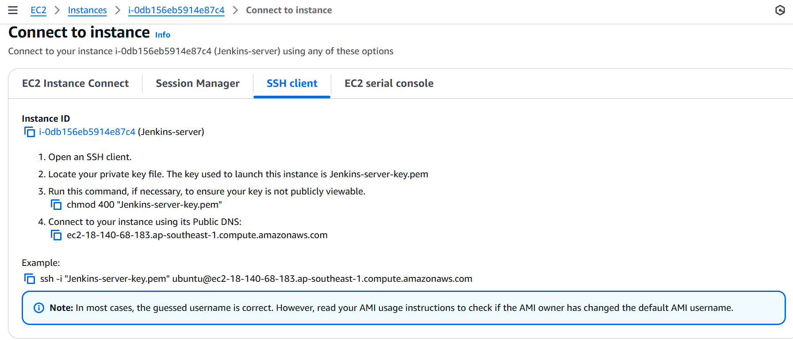

# open new terminal  




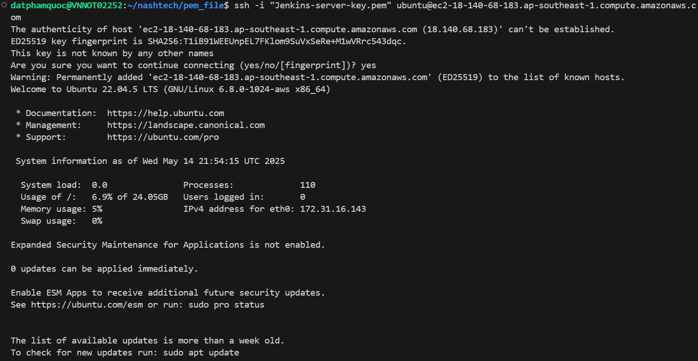

**Install Jenkins in EC2**

**Install JDK**

sudo apt update  


sudo apt install openjdk-17-jre –y  


sudo apt install openjdk-17-jdk

**Install Jenkins**

curl -fsSL https://pkg.jenkins.io/debian-stable/jenkins.io-2023.key | sudo tee \

/usr/share/keyrings/jenkins-keyring.asc > /dev/null

echo deb [signed-by=/usr/share/keyrings/jenkins-keyring.asc] \

https://pkg.jenkins.io/debian-stable binary/ | sudo tee \

/etc/apt/sources.list.d/jenkins.list > /dev/null

sudo apt-get update

sudo apt-get install jenkins –y  
  
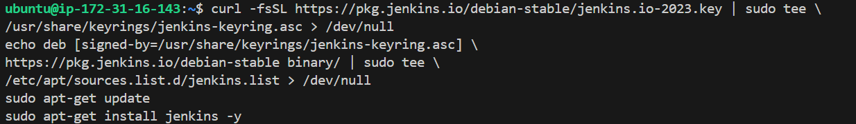





# Open web browser then access: <http://ec2-18-140-68-183.ap-southeast-1.compute.amazonaws.com:8080/>

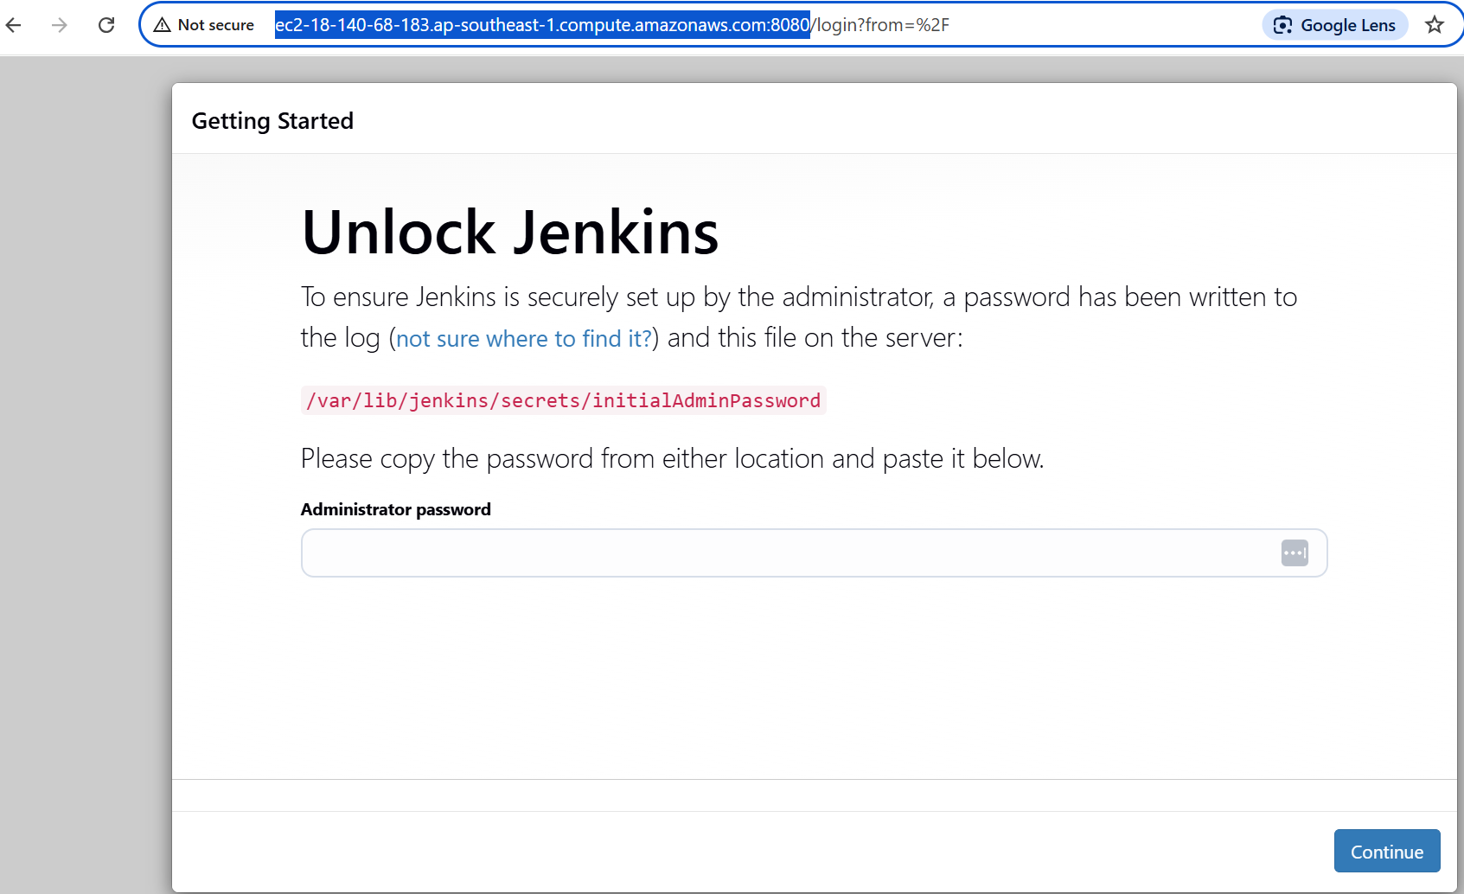

# get **Administrator password**

sudo systemctl status jenkins

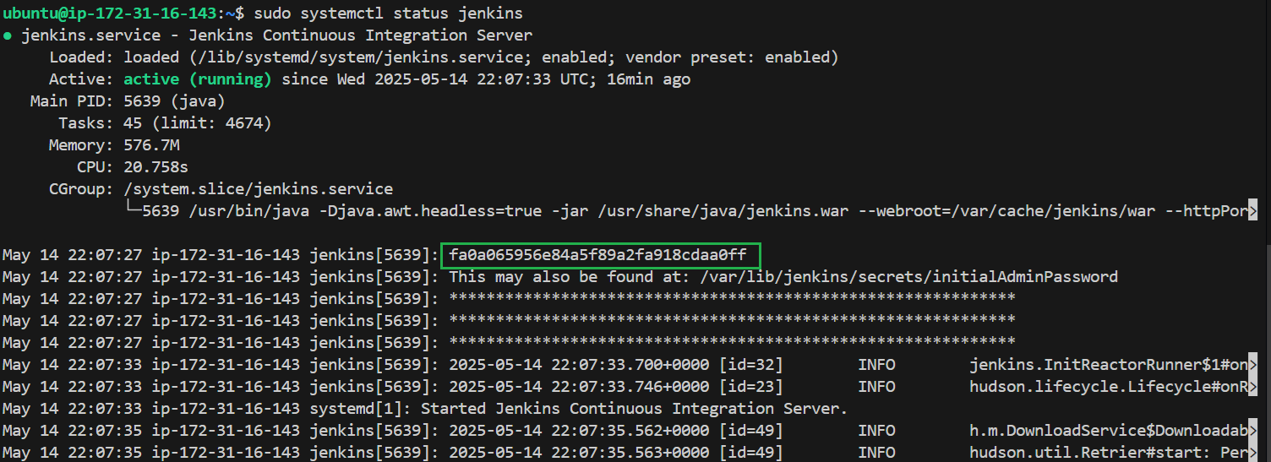

Jenkins Server has

* installed some
  + Plugins:
    - Jenkins suggested (Will install when login first time)

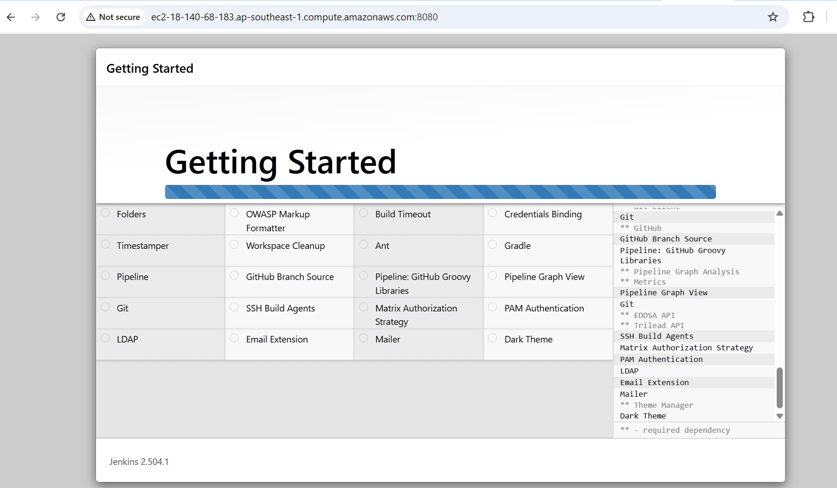

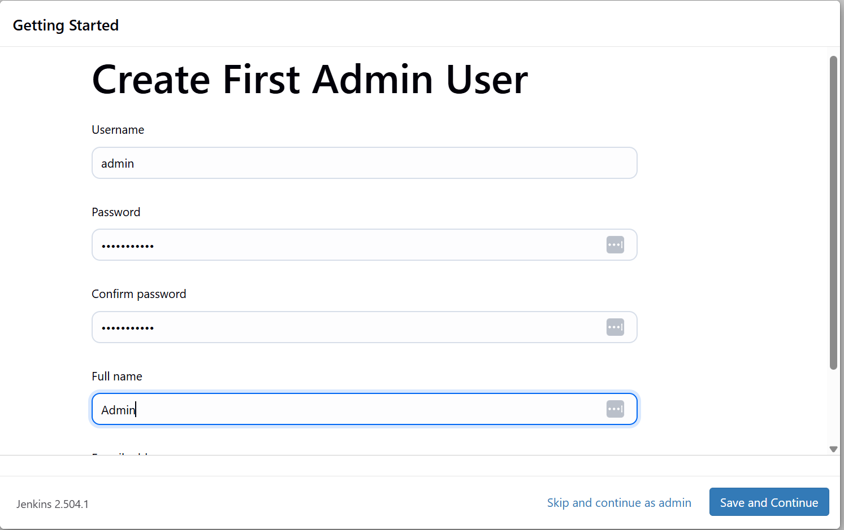

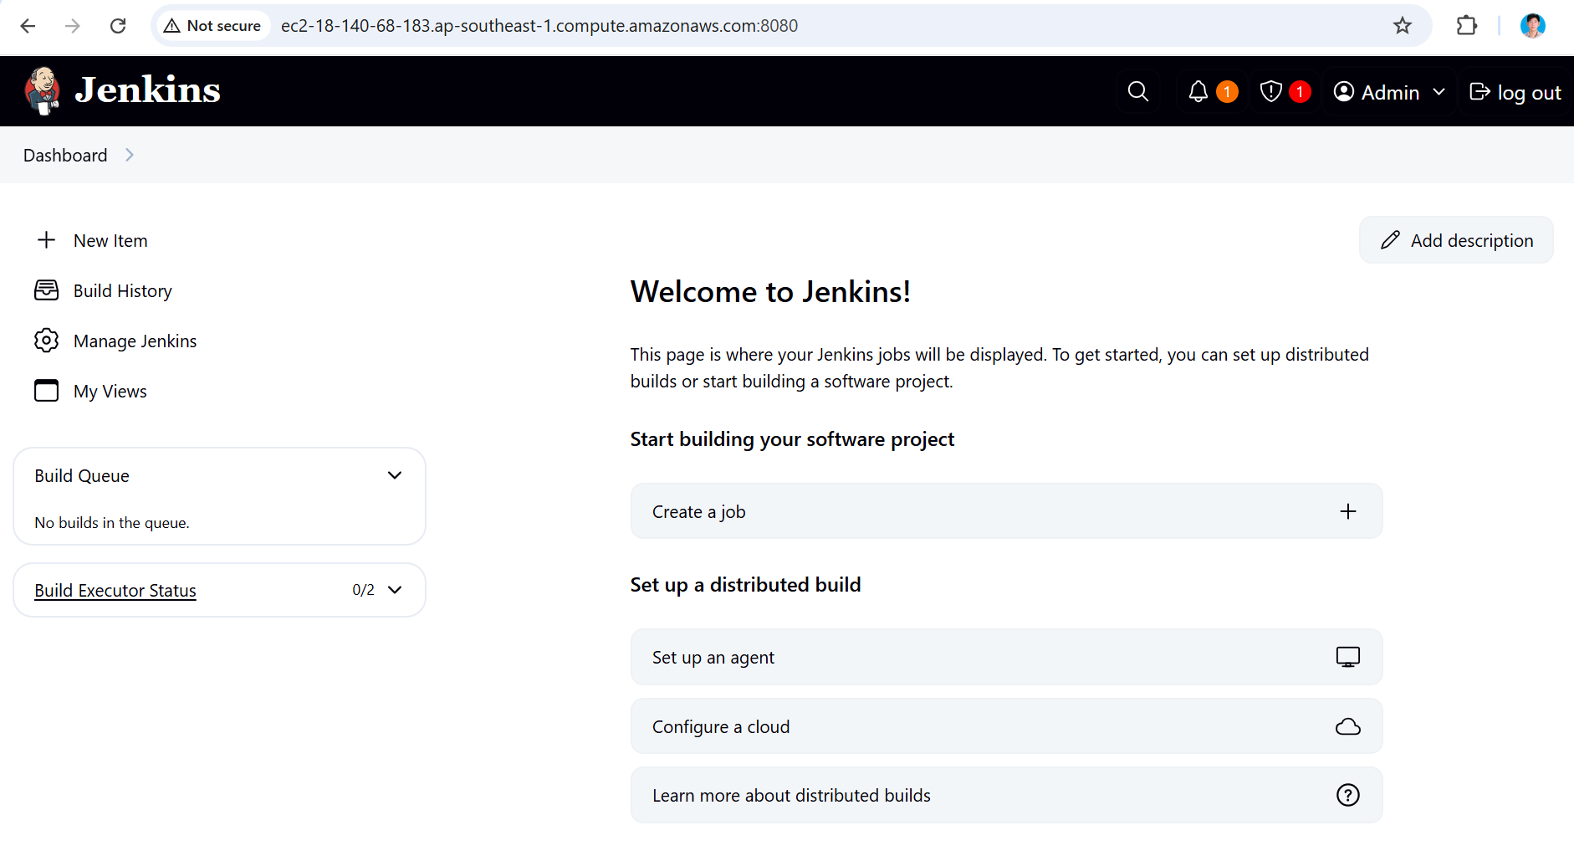

**Install AWS Credential plugin**  
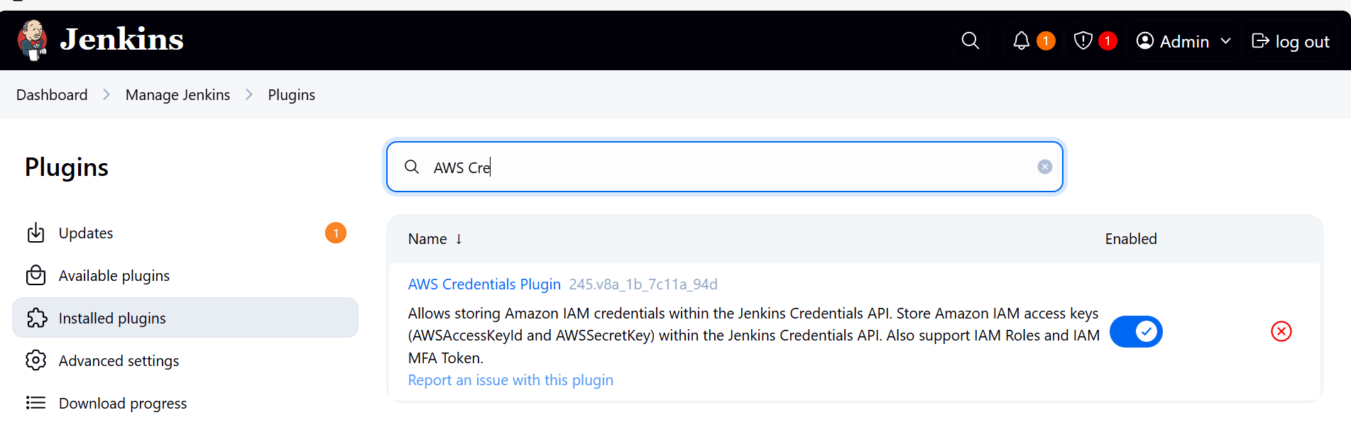

**Install HTML Publisher plugin**

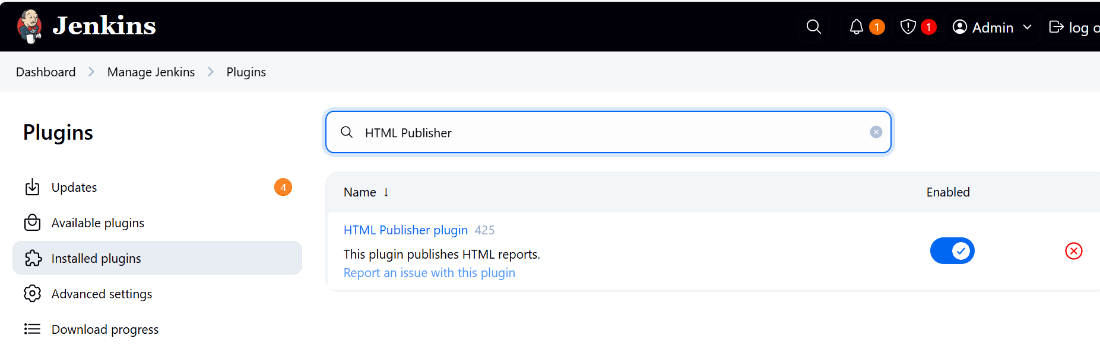

**Add Github credential and AWS credential**  
Navigate to [http://JenkinIP:8080/manage/credentials/store/system/domain/_/](http://jenkinip:8080/manage/credentials/store/system/domain/_/)  
  
For Github:   
username: github username  
password: generate the new token with full permissions ( https://github.com/settings/tokens )

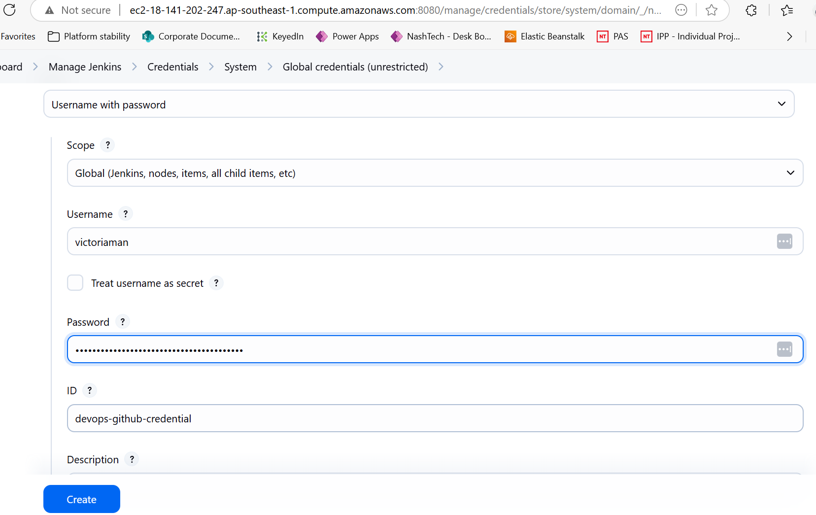

For AWS credential  
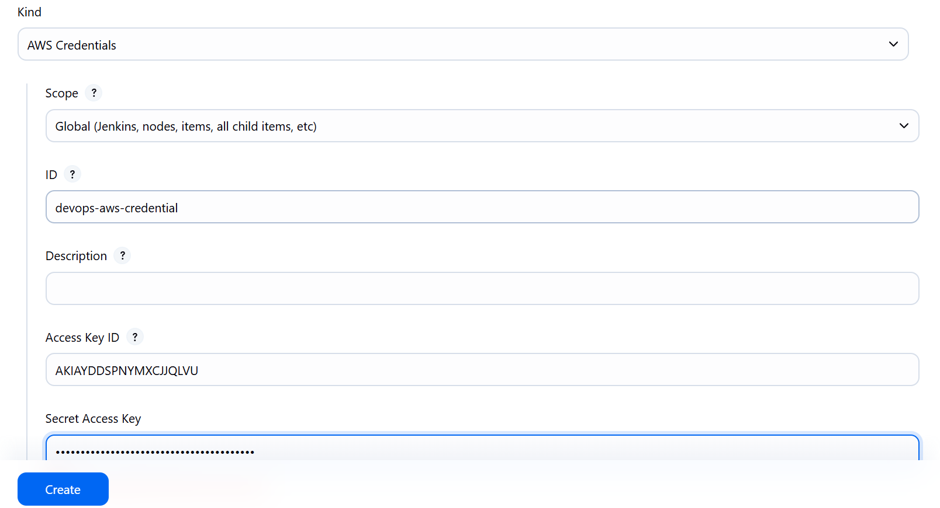

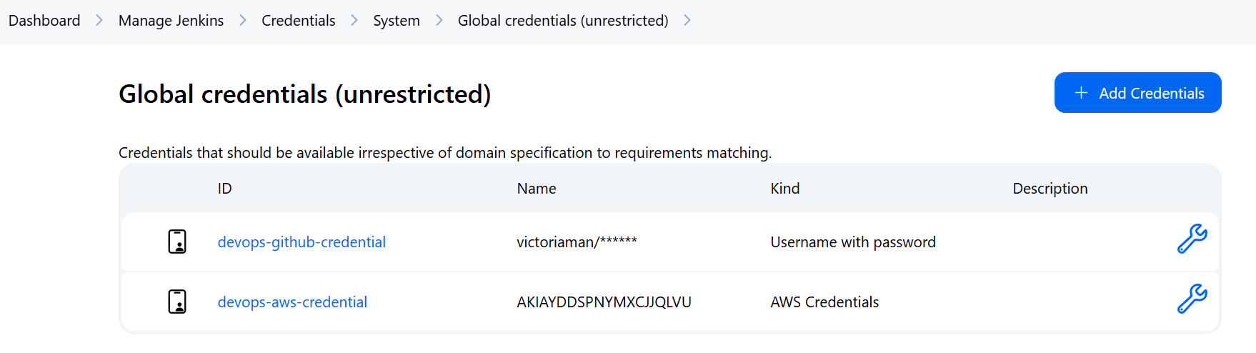

**Setup the Jenkins System to connect Github and shared libaries**: [http://JenkinIP:8080/manage/configure](http://jenkinip:8080/manage/configure)

* GitHub Enterprise Servers
  + API endpoint: [https://api.github.com](https://api.github.com/)
  + Name: github

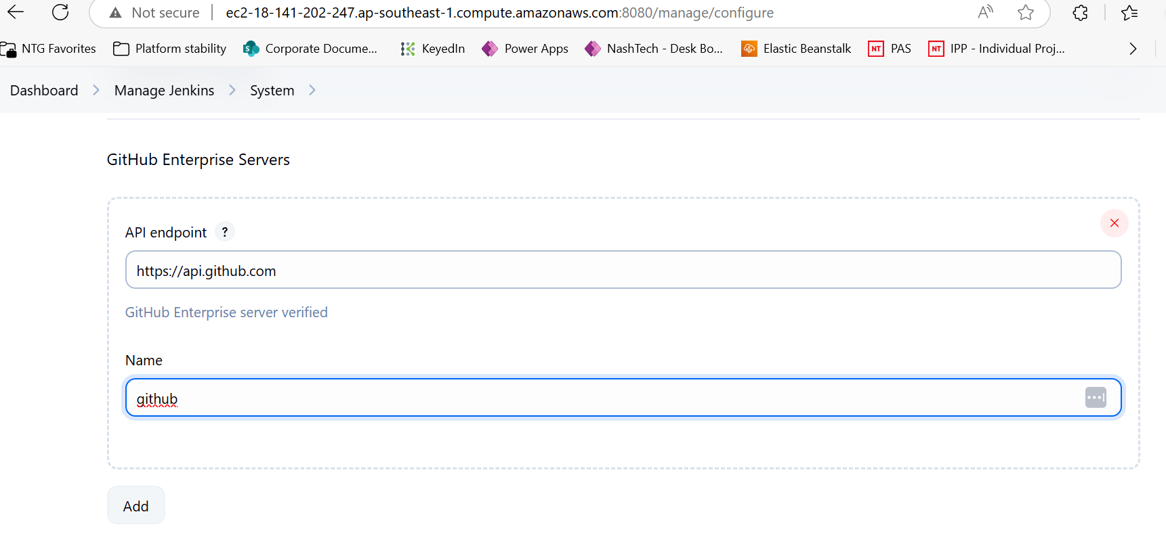

**Global Pipeline Libraries**

* Name: jenkins-devops-ci
* Default version: main
*  Allow default version to be overridden
*  Include @Library changes in job recent changes
* Retrieval method: Modern SCM
  + Source Code Management: Git
  + Project Repository: https://github.com/victoriaman/sd3500_jenkins_devops_ci.git
  + Credentials: devops-github-credential

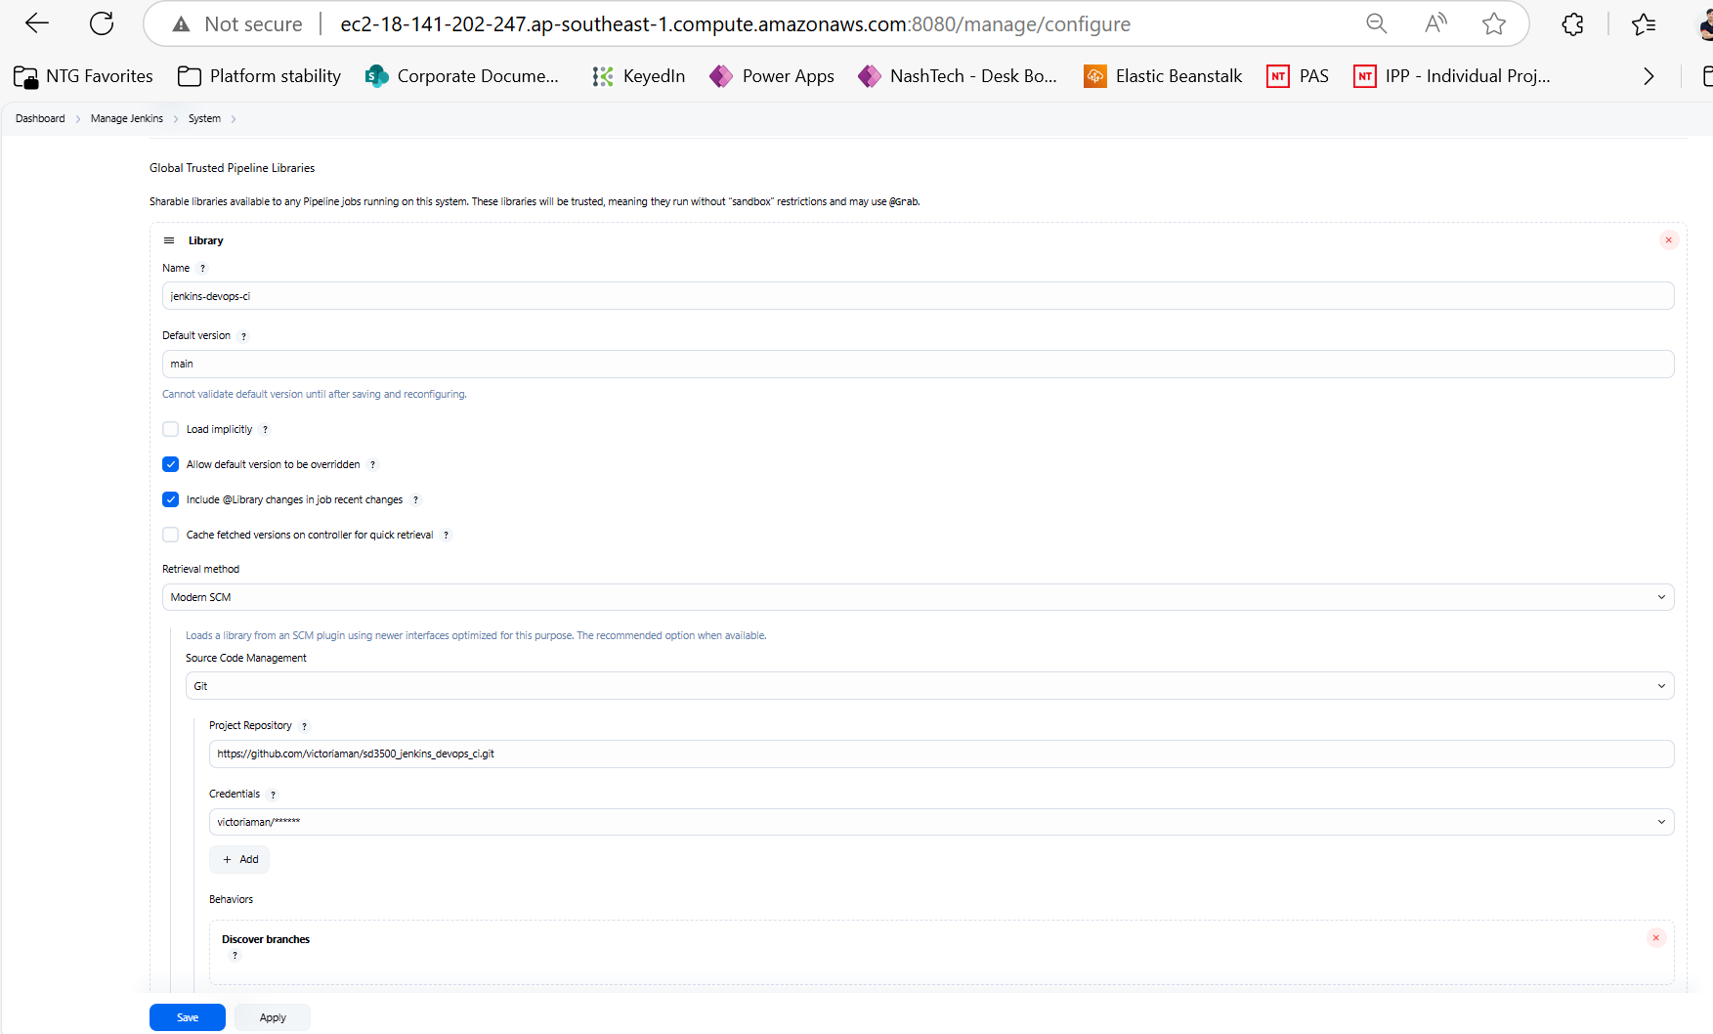

**Create pipeline in Jenkins**  
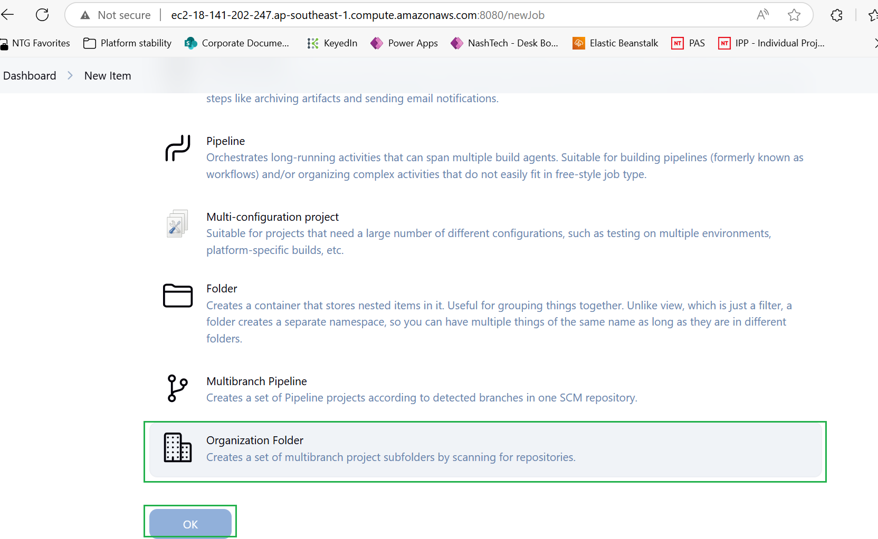

Keep everything default except below configuration

* Projects:
  + Repository Sources: GitHub Organization
    - API endpoint: Github
    - Credentials: github
    - Owner: GitHub Organization or GitHub User Account

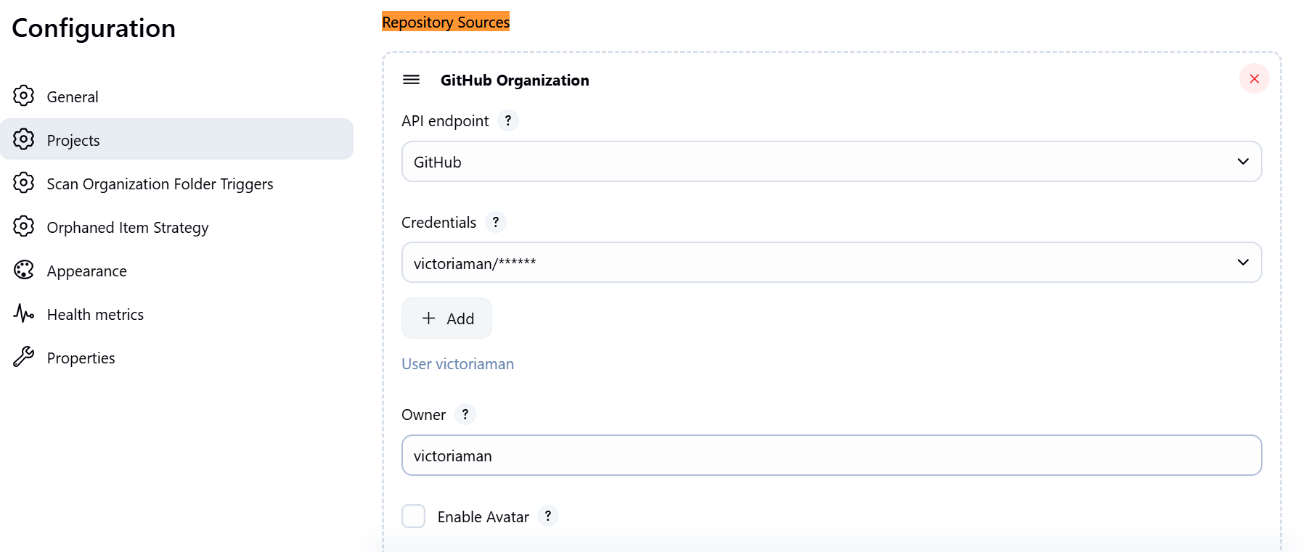

Save configuration and the jenkin will scan the entire organization to find the repositories it contains the Jenkinfile

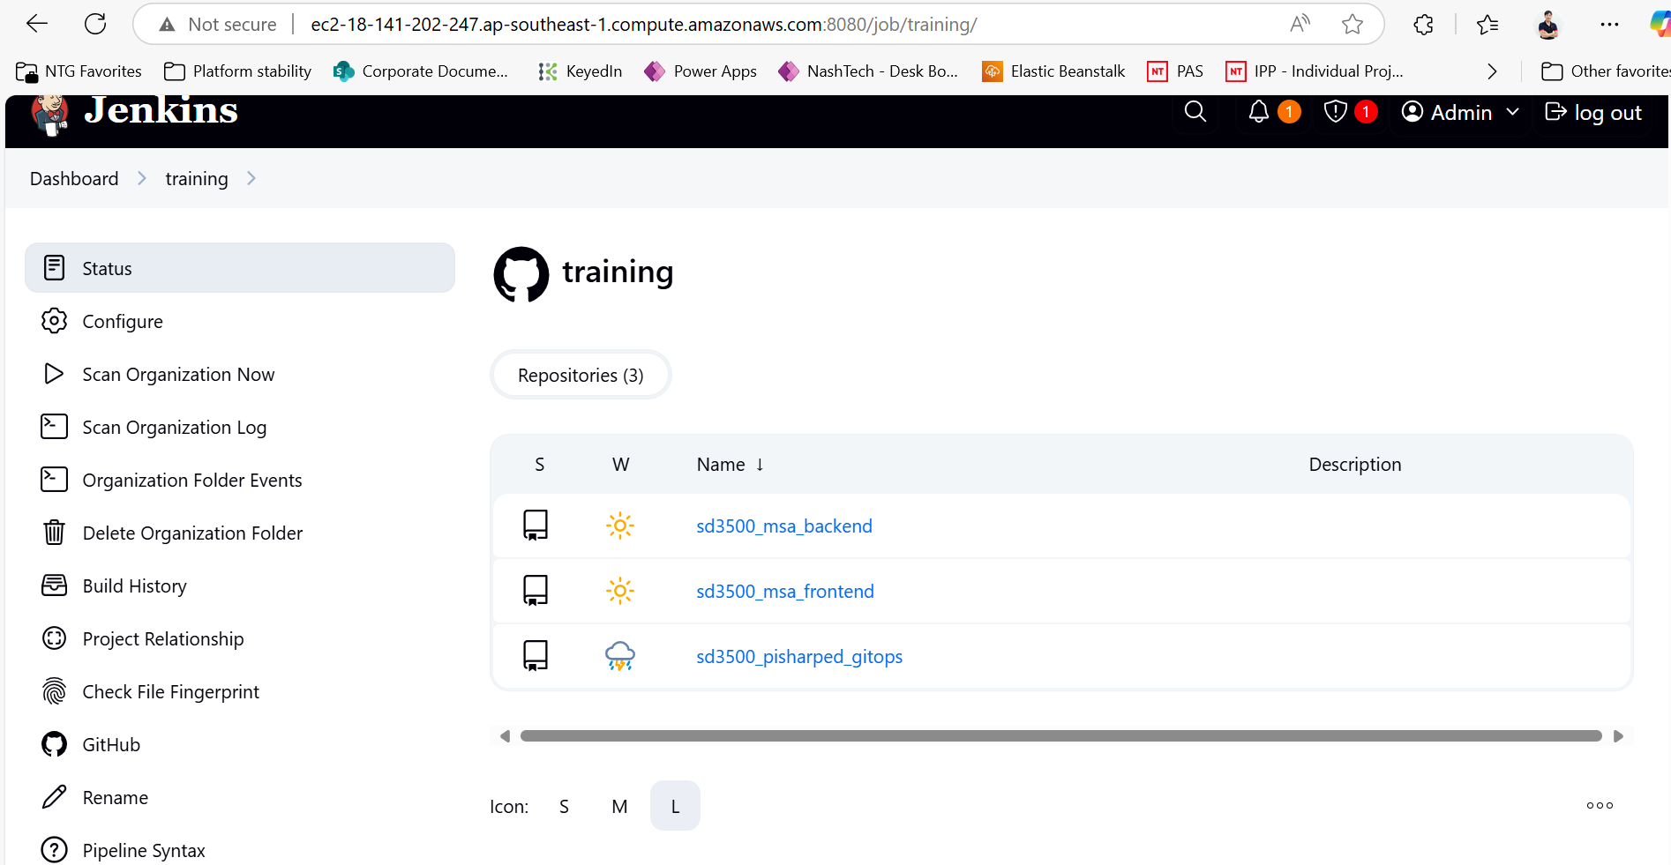

**Install Docker in EC2**

sudo apt-get update  
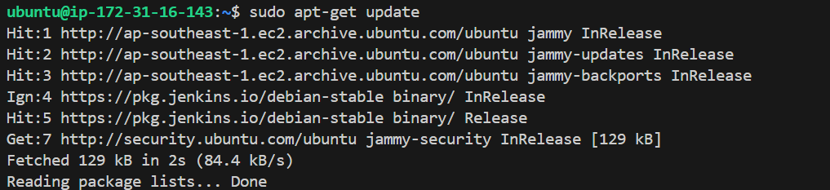

sudo apt-get install ca-certificates curl gnupg  
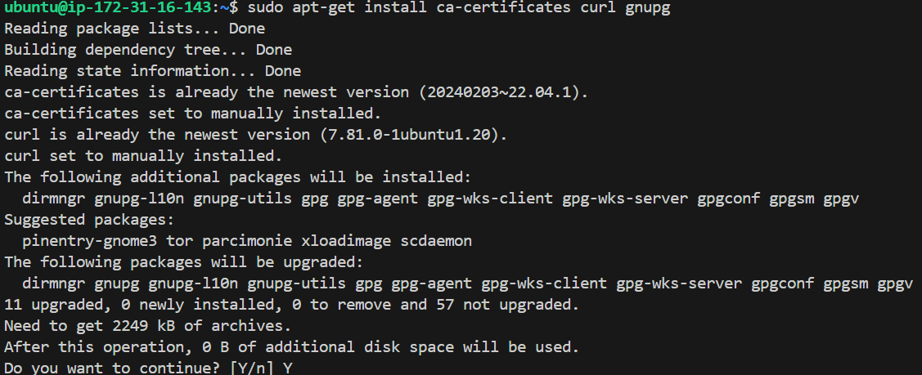

sudo install -m 0755 -d /etc/apt/keyrings  


curl -fsSL https://download.docker.com/linux/ubuntu/gpg | sudo gpg --dearmor -o /etc/apt/keyrings/docker.gpg  


sudo chmod a+r /etc/apt/keyrings/docker.gpg  


Add the repository to Apt sources:



sudo apt-get update  
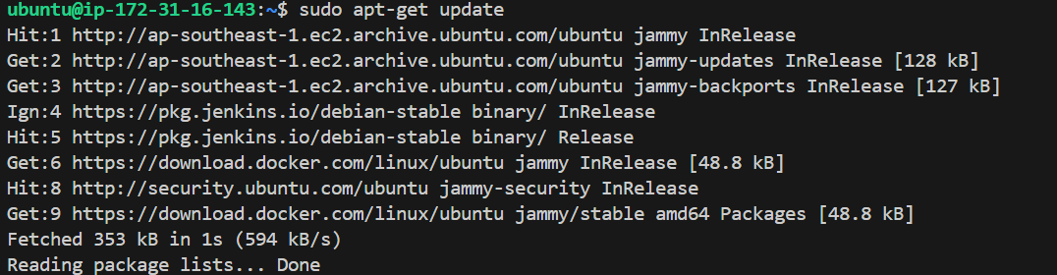

sudo apt-get install docker-ce docker-ce-cli containerd.io docker-buildx-plugin docker-compose-plugin  
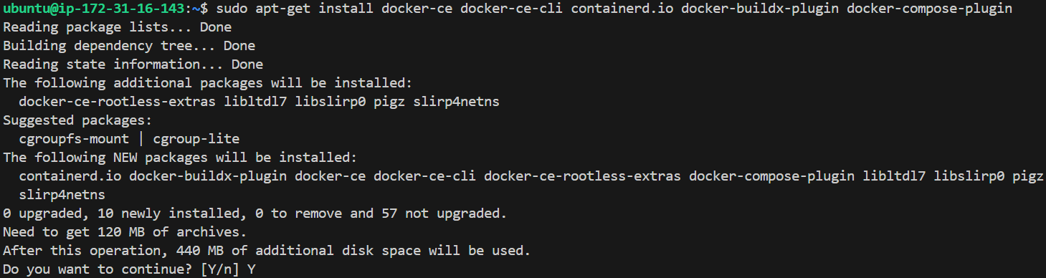

# check docker version  


# check docker compose version  


# add Jenkins user into docker group

sudo usermod -aG docker jenkins

sudo usermod -aG docker $USER

**Install git**

sudo apt-get install git-all

**Install Trivy**  
sudo apt-get install wget apt-transport-https gnupg lsb-release  
  
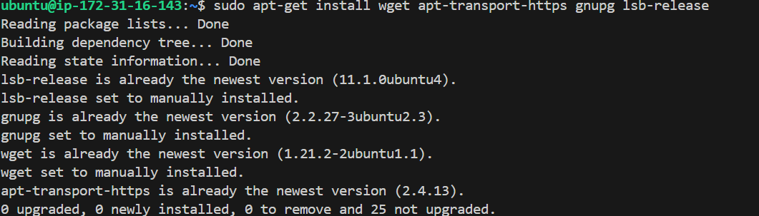

wget -qO - https://aquasecurity.github.io/trivy-repo/deb/public.key | sudo apt-key add -

echo deb https://aquasecurity.github.io/trivy-repo/deb $(lsb_release -sc) main | sudo tee -a /etc/apt/sources.list.d/trivy.list



sudo apt-get update  
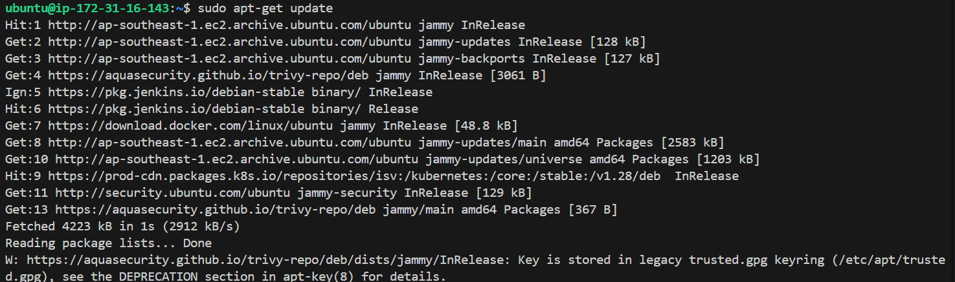

sudo apt-get install trivy

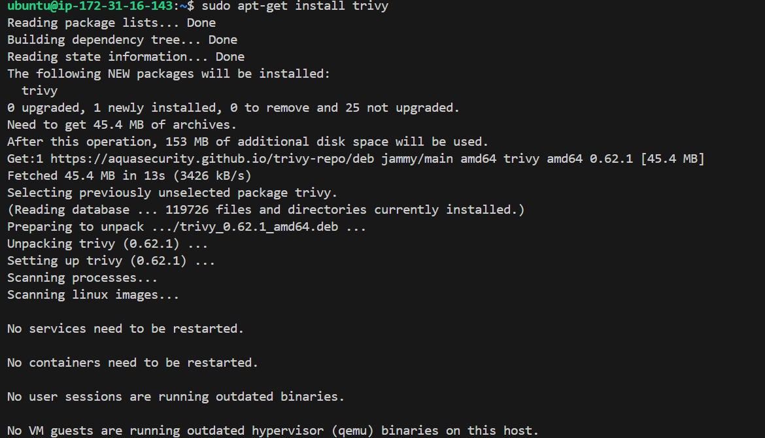

trivy --version



**Install NPM**  
sudo apt update

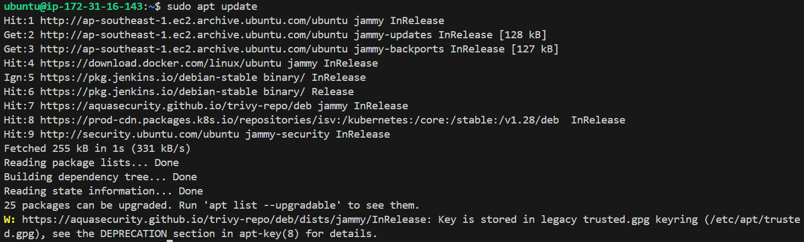

# add the NodeSource repository for Node.js (includes npm)  
curl -fsSL https://deb.nodesource.com/setup_18.x | sudo -E bash –

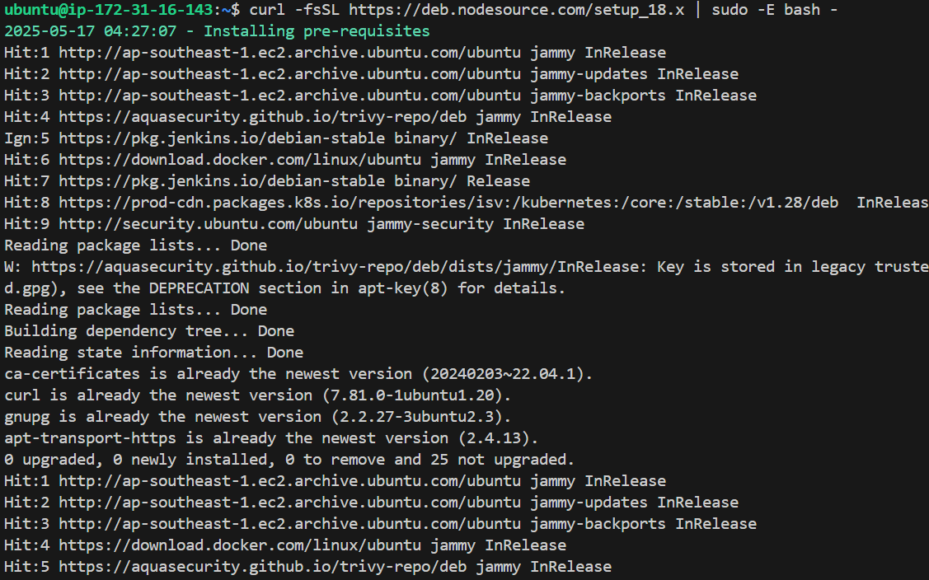

# install Node.js and npm:

sudo apt install -y nodejs  
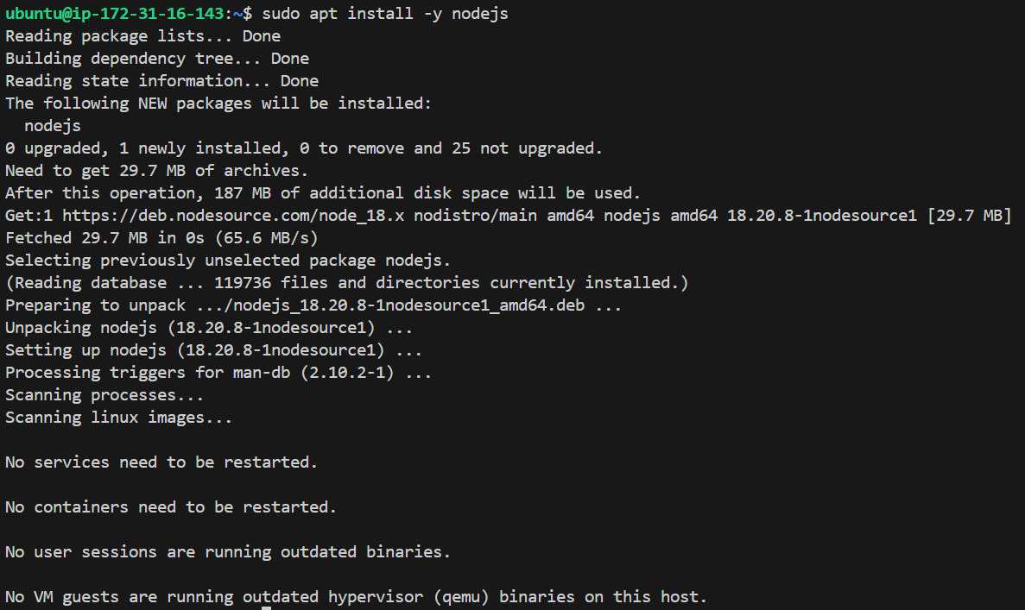

# verify installation:

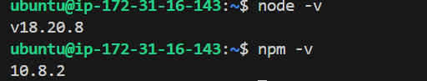

**Install AWS CLI**

sudo apt update  
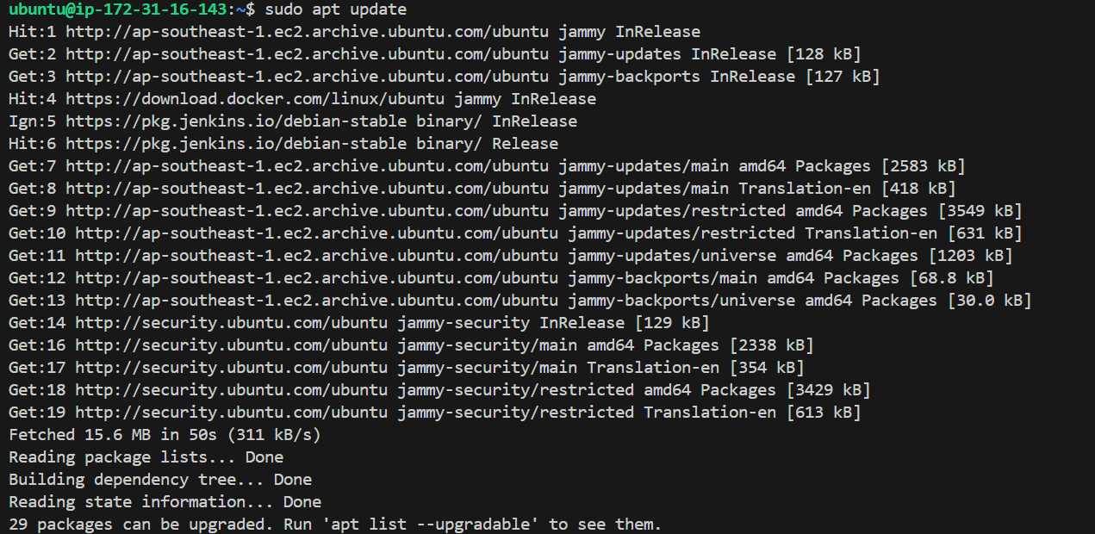

sudo apt install -y unzip curl

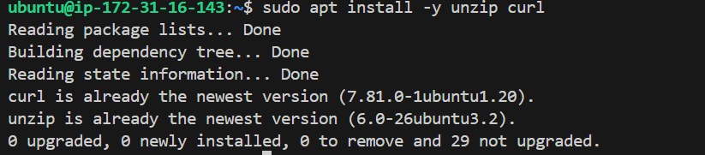

# download AWS CLI v2 installer

curl "https://awscli.amazonaws.com/awscli-exe-linux-x86_64.zip" -o "awscliv2.zip"



# unzip and install

unzip awscliv2.zip

sudo ./aws/install



# verify installation

aws –version  


**Install kubectl**

# update your system

sudo apt update  
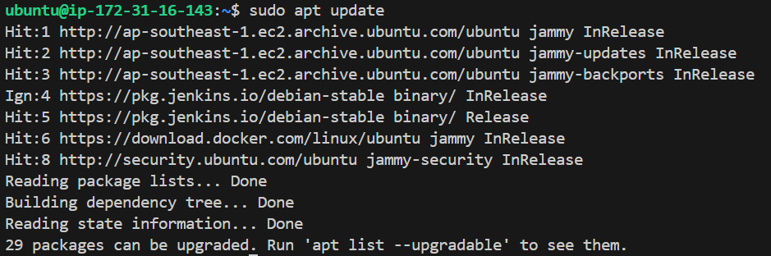

sudo apt install -y apt-transport-https ca-certificates curl   
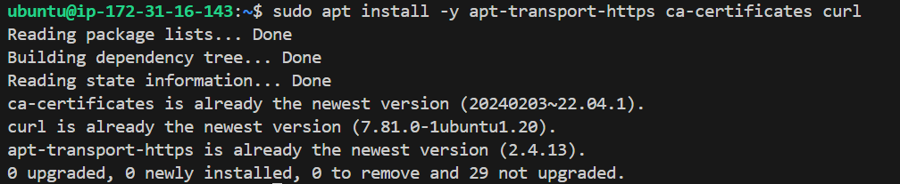

# download the Google Cloud public signing key  
sudo curl -fsSLo /usr/share/keyrings/kubernetes-archive-keyring.gpg \ https://packages.cloud.google.com/apt/doc/apt-key.gpg  
  


# Add the Kubernetes APT repository  
echo "deb [signed-by=/etc/apt/keyrings/kubernetes-apt-keyring.gpg] https://pkgs.k8s.io/core:/stable:/v1.28/deb/ /" | sudo tee /etc/apt/sources.list.d/kubernetes.list

mkdir /etc/apt/keyrings # if needed

curl -fsSL https://pkgs.k8s.io/core:/stable:/v1.28/deb/Release.key | sudo gpg --dearmor -o /etc/apt/keyrings/kubernetes-apt-keyring.gpg

# Update package list and install kubectl  
sudo apt update

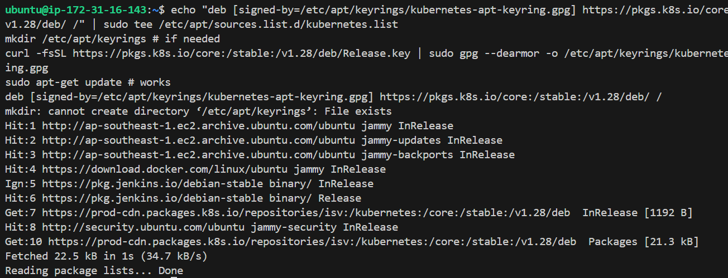

sudo apt install -y kubectl

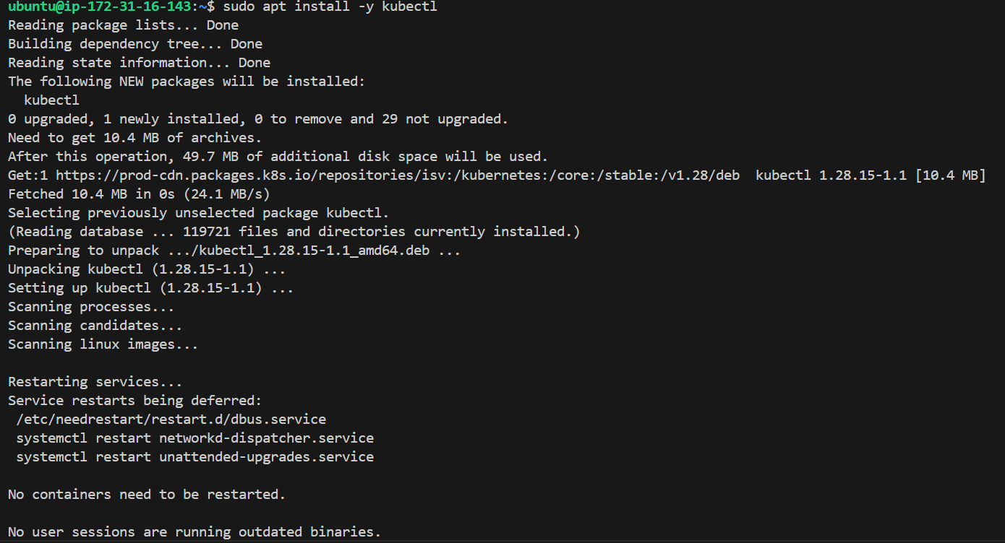

# verify

kubectl version –client

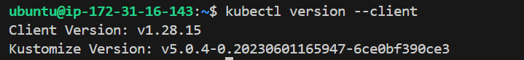

Verify CI work flow  
  
Make any change in **develop** branch in <https://github.com/victoriaman/sd3500_msa_frontend>  
  
